Removed since it is not our data. It is from TCGA project, we can provide it as supplementary.

**In original chinese manuscript, ...without the adjustment for gender,**

**age and smoking status and alcohol status, and stages.**

**But in original figure legend ...without the adjustment for gender, age and smoking status and alcohol status, and no stage mentioned.**

**In the results and discussion, I included stage. If not correct, please changed.**

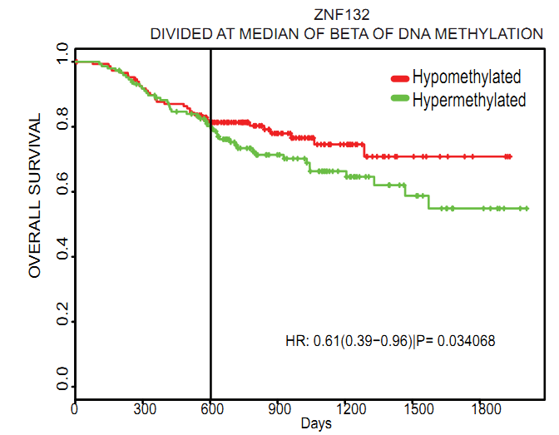

**Figure 3.** Relationship between methylation status of ZNF132 in ESCC tissues and overall survival time of patients. Overall survival time of ESCC patients with hypermethylated ZNF132 in tumor tissues was significant shorter than patients with hypomethylated ZNF132.

**Some authors put number of hypomethylated or hypermethylated cases next to red or green lines.**